07 - Functions

Dept of Artificial Intelligence and Machine Learning | Rajalakshmi Engineering College

. 95

Ex. No. : 7.1 Date: 20/4/24

Register No.: 231501058 Name: M Harish

Abundant Number

An abundant number is a number for which the sum of its proper divisors is greater than the number itself. Proper divisors of the number are those that are strictly lesser than the number.

Input Format:
Take input an integer from stdin
Output Format:

Return Yes if given number is Abundant. Otherwise, print No Example input:

12
Output:
Yes
Explanation

The proper divisors of 12 are: 1, 2, 3, 4, 6, whose sum is 1 + 2 + 3 + 4 + 6 = 16. Since sum of proper divisors is greater than the given number, 12 is an abundant number.

Example input:
13

Output:
No
Explanation

The proper divisors of 13 is: 1, whose sum is 1. Since sum of proper divisors is not greater than the given number, 13 is not an abundant number. For example:

Test Result
print(abundant(12)) Yes
print(abundant(13)) No

PROGRAM

def abundant(n):

sum=0

for i in range(1,n):

if n%i==0:

sum+=i

if sum>n:

return ("Yes")

else:

return ("No")

Dept of Artificial Intelligence and Machine Learning | Rajalakshmi Engineering College

. 96

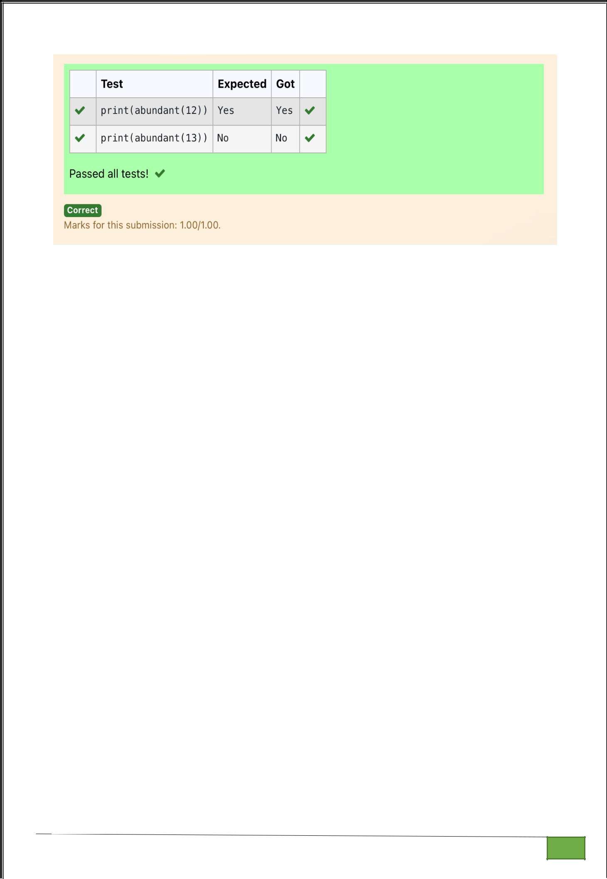

Dept of Artificial Intelligence and Machine Learning | Rajalakshmi Engineering College

. 97

Ex. No. : 7.2 Date: 20/4/24

Register No.: 231501058 Name: M Harish

Automorphic number or not

An automorphic number is a number whose square ends with the number itself. For example, 5 is an automorphic number because 5*5 =25. The last digit is 5 which same as the given number.

If the number is not valid, it should display “Invalid input”.

If it is an automorphic number display “Automorphic” else display “Not Automorphic”.

Input Format:
Take a Integer from Stdin

Output Format:

Print Automorphic if given number is Automorphic number, otherwise Not Automorphic

Example input: 5 Output: Automorphic Example input: 25 Output: Automorphic
Example input: 7 Output: Not Automorphic

For example:
Test Result
print(automorphic(5)) Automorphic

PROGRAM

def automorphic(n):

if(n==((n**2)%10)):

return("Automorphic")

else:

return("Not Automorphic")

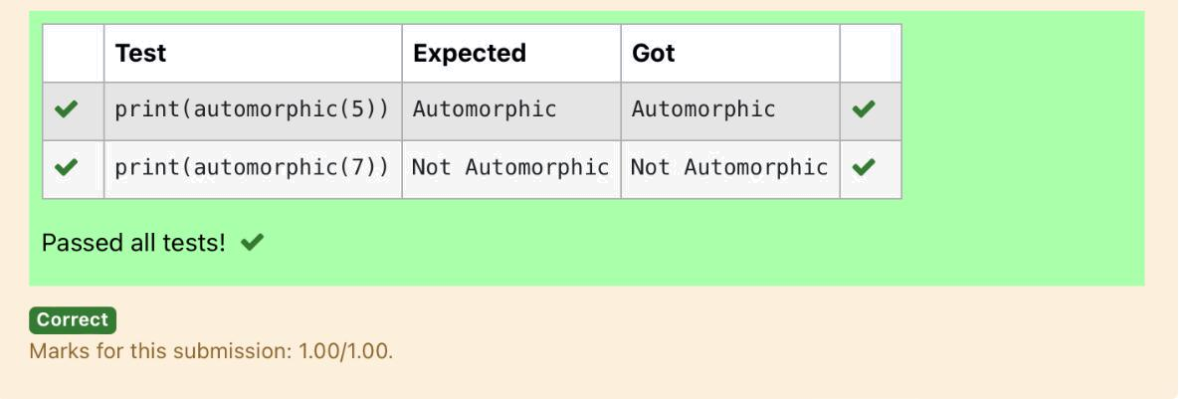

Dept of Artificial Intelligence and Machine Learning | Rajalakshmi Engineering College

. 98

Ex. No. : 7.3 Date: 20/4/24

Register No.: 231501058 Name: M Harish

Check Product of Digits

Write a code to check whether product of digits at even places is divisible by sum of digits at odd place of a positive integer.

Input Format:
Take an input integer from stdin.

Output Format:
Print TRUE or FALSE.
Example Input:
1256
Output:
TRUE

Example Input:
1595
Output:
FALSE
For example:

PROGRAM

def productDigits(n):

s=str(n)

sum=0

for j in range(1,len(s)):

if(j%2!=0):

sum+=int(s[j])

sum1=0

while(n>0):

n1=n%10

n=n//10

sum1+=n1

if(sum1%sum==0):

return False

else:

return True

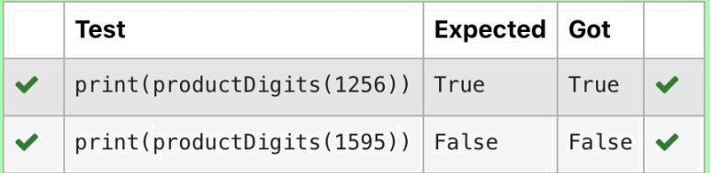

Test |  | Result
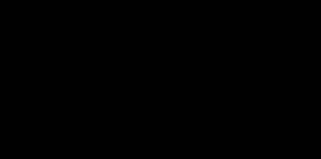


print(productDigits(1256)) True

print(productDigits(1595)) False

Dept of Artificial Intelligence and Machine Learning | Rajalakshmi Engineering College

. 99

Ex. No. : 7.4 Date: 20/4/24

Register No.: 231501058 Name: M Harish

Christmas Discount

An e-commerce company plans to give their customers a special discount for Christmas.

They are planning to offer a flat discount. The discount value is calculated as the sum of all the prime digits in the total bill amount.

Write an python code to find the discount value for the given total bill amount.

Constraints

- <= orderValue< 10e100000 Input

The input consists of an integer orderValue, representing the total bill amount. Output

Print an integer representing the discount value for the given total bill amount.

Example Input

578

Output

12

For example:

Test | Result
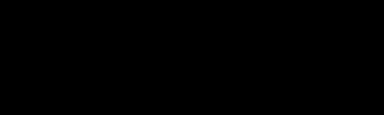


print(christmasDiscount(578)) | 12

PROGRAM

def christmasDiscount(n):

count=0

sum=0

while(n>0):

count=0

n1=n%10

n=n//10

for i in range(2,n1):

if(n1%i==0):

count=1

if(count==0):

sum+=n1

return sum

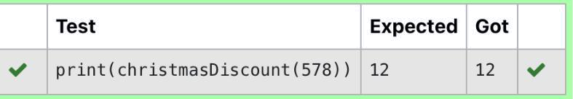

Dept of Artificial Intelligence and Machine Learning | Rajalakshmi Engineering College | . 100

Ex. No. : 7.5 Date: 20/4/24

Register No.: 231501058 Name: M Harish

Coin Change

complete function to implement coin change making problem i.e. finding the minimum

number of coins of certain denominations that add up to given amount of money. The only available coins are of values 1, 2, 3, 4

Input Format:

Integer input from stdin.

Output Format:

return the minimum number of coins required to meet the given target.

Example Input:

16

Output:

4

Explanation:

We need only 4 coins of value 4 each

Example Input:

25

Output:

7

Explanation:

We need 6 coins of 4 value, and 1 coin of 1 value

PROGRAM

def coinChange(n):

coins = [4, 3, 2, 1]

count = 0

for coin in coins:

count += n // coin

n %= coin

return count

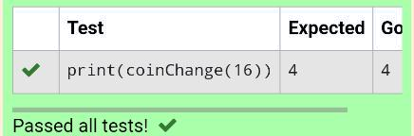

Dept of Artificial Intelligence and Machine Learning | Rajalakshmi Engineering College

. 101

Ex. No.

:
7.6
Date: 20/4/24

Register No.: 231501058

Name: M Harish

Difference Sum

Given a number with maximum of 100 digits as input, find the difference between the sum of odd and even position digits.

Input Format:

Take a number in the form of String from stdin.

Output Format:

Print the difference between sum of even and odd digits

Example input:

1453

Output:

1

Explanation:

Here, sum of even digits is 4 + 3 = 7

sum of odd digits is 1 + 5 = 6.

Difference is 1.

Note that we are always taking absolute difference

PROGRAM

def differenceSum(n):

st=str(n)

evensum=0

oddsum=0

for i in st:

if int(i)%2==0:

evensum+=int(i)

else:

oddsum+=int(i)

return abs(evensum-oddsum)

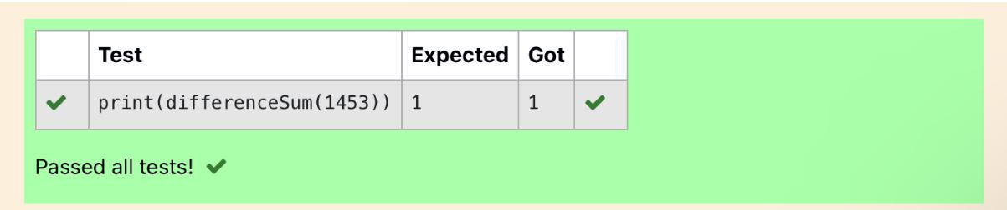

Dept of Artificial Intelligence and Machine Learning | Rajalakshmi Engineering College | . 102

Ex. No. : 7.7 Date: 20/4/24

Register No.: 231501058 Name: M Harish

Ugly number

A number is considered to be ugly if its only prime factors are 2, 3 or 5. [1, 2, 3, 4, 5, 6, 8, 9, 10, 12, 15, …] is the sequence of ugly numbers. Task:

complete the function which takes a number n as input and checks if it's an ugly number. return ugly if it is ugly, else return not ugly Hint:

An ugly number U can be expressed as: U = 2^a * 3^b * 5^c, where a, b and c are nonnegative integers.

For example:

Test | Result
print(checkUgly(6)) | ugly
print(checkUgly(21)) | not ugly

PROGRAM

def checkUgly(n):

while n % 2 == 0:

n //= 2

while n % 3 == 0:

n //= 3

while n % 5 == 0:

n //= 5

return "ugly" if n == 1 else "not ugly"

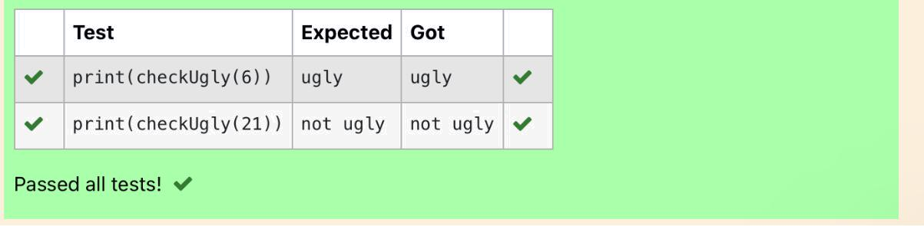

Dept of Artificial Intelligence and Machine Learning | Rajalakshmi Engineering College

. 103

